PRINCIPAL'S MESSAGE

OCTOBER 2019

“Stories often shape your understanding of the world.”

I already knew this, but it has been confirmed, Kauri Sue is indeed an amazing place. I need to thank the staff for their dedication to making the school year start up as smooth as possible despite a few bumps in the road. As Summer turns to Autumn, and the green changes to shades of orange, gold and red, we continue our journey through the 2019-2020 school year and towards all of the exciting times that lie ahead. As we begin to settle into October, teaching, learning and IEP’s are in full swing. It has been fun to talk with many of you and reminisce since being back…”Remember when…?” and we laugh and groan. I believe that personal stories are a key starting point when we share life-changing moments we touch other people more than we know. Stories teach us to love, to forgive others, to be just and to strive for better than we have. I think back over the many students I have had the privilege to work with over the years and all the amazing things they have done. In many ways, we have become a form of family, bonded through common experiences. As we struggle through challenges and celebrate triumphs together please continue to share your stories with us. Thanks for being a part of the Kauri Sue family.

Save the Date!

- October 4th- “Boo to the Flu” clinic in the Kauri Sue Hamilton Cafeteria 2:30 p.m.– 6:00 p.m.
- October 16th- Picture Day
- October 21-25- Fall Recess, No School
- October 28th – No School – All Grade Transmittal Day
- October 29th – Pumpkins from the Utah State Prison
- October 31st- Halloween Parade, 10:30-11:30 in the Atrium

Reach for the Stars!!!

Let your voice be heard!
DSPD invites people with disabilities to share your opinions and ideas with us. We are hosting five focus groups that you can attend in-person or online. All of the focus groups will be located at 195 N 1950 W Salt Lake City, UT, 84116. Read the focus group descriptions below. Then fill out the form to register for the focus groups that you want to attend. Web address: https://docs.google.com/forms/d/e/1FAIpQLScAodp9KRAPbMsIC5cto9q3azRuVJ6Y8WKZW_v7ESQiG-zK- A/viewform

Caregiver Compensation
October 2, 2019, 3-5 pm
The Utah Department of Health is conducting a study for our state legislature about paying parents and spouses to care for their loved ones. DSPD is helping get information for the Department of Health by asking you and other families about caregiving. DSPD wants to hear from you about (1) the help that you receive; (2) what your needs are; (3) what stops you from getting the help that you need; and (4) who you want to help you every day.

Technology First
October 9, 2019, 3-5 pm
DSPD is interested in using technology, like video calls, cameras, and smart devices, to support your independence. We want to know what you think about technology. We will ask you questions about (1) what devices you use; (2) your opinion on a few different technologies; (3) your privacy; and (4) other concerns that you have.

Nursing Services
October 16, 2019, 3-5 pm
DSPD wants to know more about your medical support needs. We will ask you questions about (1) who helps you; (2) what your medical needs are; (3) if you get enough help with your medical needs; and (4) if you want more help.

Service Design
October 23, 2019, 3-5 pm
DSPD wants to know about the help that you need every day. We will ask you questions about (1) the help that you receive; (2) what your needs are; (3) what you like about the help that you receive; (4) what you do not like about the help that you receive; (5) the things that you want to do each day; and (6) where you want to go every day.

Integrated Community Programs
October 28, 2019, 3-5 pm
DSPD wants to know about activities that you want to do during the day. We will ask you questions about (1) your community; (2) what you like to do; (3) new things that you want to try; (4) going to work; and (5) where you want to go every day.

Say Hello to the Transition Specialist at Kauri Sue Hamilton!

Hello, I’m Jen and I’ve been at KSHS since 2014. I’ve worked with most of the of students here and I’ve loved every minute of it. I have been given the opportunity to support our students ages 14-22 in their transition into independence/world. I will be teaching them real world routines, skills, and finding them job opportunities in the community, as well as within the school. I am very excited to be working with our students!

This month we will be working on survival signs. When you’re out in the community, take a second to point out signs such as stop, bathroom, and crosswalk signs! Practice makes perfect! If you have any ideas, questions, or concerns please email me at jenifer.workman@jordandistrict.org

October Speech and Language News
We are excited to continue with our Word of the Week program. Core vocabulary words we will be using in October include ‘wait, my turn, your turn’. Students will practice waiting for highly desirable items such as to take a turn during a game or to get a treat. Some helpful cues to assist your child with waiting include reminders for them to listen for their name, watching a clock tic down (App suggestion: Visual Timer by Yong) while brushing teeth, or counting to a particular number (e.g. 1… 2… 3… Go) to be able to go outside. These activities naturally lead into turn taking. We take turns all day long with our students such as moving rain sticks in music, throwing balls in PE, and vacuuming in functional groups with Occupational Therapy.
We take turns talking, too! What do you do at home with your child that includes taking turns? Do you know how your child can request a turn? If not, reach out to your child’s classroom teachers or speech therapist to find out how you can help them request a turn.
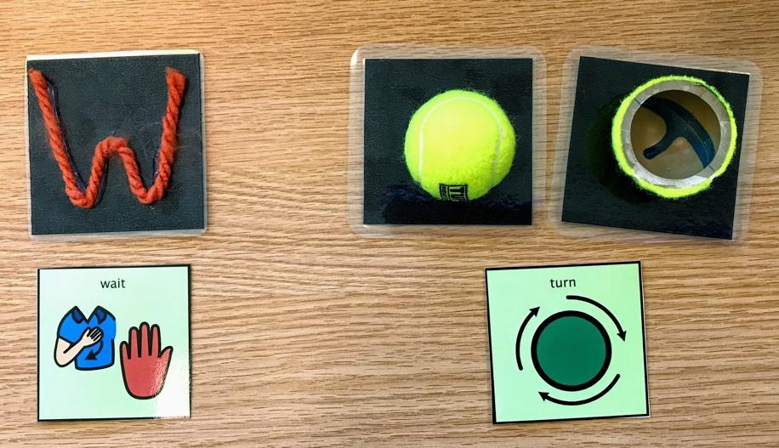

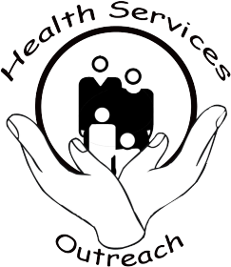

JORDAN SCHOOL DISTRICT HEALTH SERVICES OUTREACH
Kauri Sue Hamilton School
2827 West 13400 South Riverton, UT 84065
(801) 567-8508 Fax (801) 567-8521

Do you need help paying your energy bills?
As it cools down outside, your home should be a place of warmth and comfort for you and your family. Jordan School District has partnered with the H.E.A.T. program (Home Energy Assistance Target), designed to help low-income families with their utility bills during the coldest months of the year. Especially those that are the most vulnerable, such as the elderly, the disabled, and households with young children.

      - applications are being accepted October 1-April 30. As a courtesy, we will help you fill out the application and submit it to the H.E.A.T. office.
Call Health Services to make an appointment Monday-Friday 8:00 am – 3:30 pm 801-567-8515.

INCOME ELIGIBILITY
Monthly Pre-tax Income Limits
Household size | H.E.A.T.  Gross Income
1 | $1,561
2 | $2,114
3 | $2,666
4 | $3,219
5 | $3,771
6 | $4,324
7 | $4,876
If more than 7 | Add $552 per person

NOTES FROM NURSING
INFLUENZA (FLU) FACTS
What is influenza (also called flu)?
The flu is a contagious respiratory illness caused by influenza viruses that infect the nose, throat, and lungs. It can cause mild to severe illness, and at times can lead to death*. The best way to prevent the flu is by getting a flu vaccine each year.
Signs and symptoms of flu
People who have the flu often feel some or all of these signs and symptoms:
        - Fever, usually over 101°F and typically chills as well
        - Bad “wet sounding” cough
        - Sore throat
        - Runny or stuffy nose
        - Severe muscle and body aches
        - Bad headache
        - Fatigue (very tired)
*Most people who get influenza will recover in a few days to less than two weeks, but some people will develop complications (such as pneumonia) as a result of the flu, some of which can be life-threatening.
How flu spreads
Most experts believe that flu viruses spread mainly by droplets made when people with flu cough, sneeze or talk. These droplets can land in the mouths or noses of people who are nearby. Less often, a person might also get flu by touching a surface or object that has flu virus on it and then touching their own mouth, eyes or possibly their nose.
Period of contagiousness
You may be able to pass on the flu to someone else before you know you are sick, as well as while you are sick. Most healthy people may be able to infect others beginning one day before symptoms develop and up to five to seven days after becoming sick. Some people, especially young children and people with weakened immune systems, might be able to infect others for an even longer time.
Prevent seasonal flu: Get vaccinated
- The single best way to prevent the flu is to get a flu vaccine each season.
- There are several flu vaccine options:
Traditional flu vaccines made to protect against three different flu viruses (called “trivalent” vaccines) are available. Trivalent flu vaccine protects against two influenza A viruses (an H1N1 and an H3N2) and an influenza B virus. In addition, flu vaccines made to protect against four

different flu viruses (called “quadrivalent” vaccines) also are available. The quadrivalent flu vaccine protects against two influenza A viruses and two influenza B viruses.
THE FLU VACCINE WILL NOT GIVE YOU THE FLU
Who Should Get Vaccinated This Season?
- Everyone 6 months of age and older should get a flu vaccine every season.
Most Importantly:
- People aged 50 years and older;
- People with chronic pulmonary (including asthma), cardiovascular (except hypertension), renal, hepatic, neurologic, hematologic, or metabolic disorders (including diabetes mellitus);
- People who are immunosuppressed (including immunosuppression caused by medications or by human immunodeficiency virus);
- Women who are or will be pregnant during the influenza season;
- People who are residents of nursing homes and other chronic-care facilities;
- Health-care personnel;
- Household contacts and caregivers of children younger than 5 years and adults aged 50 years and older, with particular emphasis on vaccinating contacts of children aged younger than 6 months; and
- Household contacts and caregivers of people with medical conditions that put them at higher risk for severe complications from influenza.
- There are certain flu shots that have different age indications. For example, people younger than 65 years of age should not get the high-dose flu shot and people who are younger than 18 years old or older than 64 years old should not get the intradermal flu shot.
Who should not be vaccinated against seasonal flu?
  - Children younger than 6 months are too young to get a flu shot
  - People with severe, life-threatening allergies to flu vaccine or any ingredient in the vaccine. This might include gelatin, antibiotics, and eggs.

