PRINCIPAL'S MESSAGE
APRIL NEWSLETTER

HOLD ON TIGHT TO EACH OTHER....The tragedy in Florida happened over 2000 miles away but it may as well have been in our own community; it rocked everyone's world and the ripple effect continues. In our district, the event prompted a review of our Incident Command System at the last Principal's Meeting. I have shared our school process with you in previous newsletters but I want to take this opportunity to share the bigger picture with you also.

- The district's Incident Command Manual includes these emergency action plans; state law requires we do 9 drills annually - each type at least once.
    - Fire/Evacuation
    - Violence:
      - Lock-Down (threat is in the building)
      - Lock-Out (threat is outside of the building)
    - Shelter-In-Place (hazardous spill or extreme weather)
    - Earthquake
    - Bomb
  - The safety and security implementation for our district includes:
    - 1996 first security cameras were installed
    - 1999 established The Incident Command System (after Columbine's massacre)
    - 2003 24-hour Alarm Response
    - 2008 Automated External Defibrillators (AED) installed
    - 2010 card access to buildings rather than keyed entry
    - January 2013 (in response to December's Sandy Hook tragedy) Jordan Safety and Security Assessments completed throughout the year for all schools; upgraded and doubled the number of digital security cameras
    - 2015 introduced the idea of Reunification plans for schools
    - 2017 SafeUT app implemented
    - 2018 Collaboration with police to improve strategies

I feel grateful to work in a district that sets a high standard for student safety and leads the way in Incident Command expectations and training. Thanks for sharing your kids with us each day. We want to assure you that we work hard to keep them safe while they are here with us at school.

Save the Date!

- April 19- The Great Utah Shake Out
- April 25- Planning for the future meeting for parents of students ages 14 and older in atrium, 6:30- 8:00 PM
- May 1- Starlight Dance for students ages 14 and older, 6:00-8:00 PM
- May 16- Graduation, 10:30 AM
- May 28- Memorial Day, no school
- JUNE 1- Last day of school

Reach for the Stars!!!

Planning for the Future – Life After Graduation
April 25, 2018, 6:30 pm– 8:00 pm
Bring the family, light meal will be served

Family Night will:
  - Provide access to agencies/resources available to families
  - Help families start planning for post school life
  - Answer questions families have about their child’s future
  - Explain and answer questions about transition and customized employment
  - Define customized employment and how it applies to your student
  - Introduce a panel of students and parents actively involved in customized employment. They will be available to answer questions or concerns you may have.
  - Help decide the “next steps”

Who should come?
Families whose student is 14 years old and older

Have questions?
Call or email your students classroom teacher
Call or email Teri Griffiths: teri.griffiths@jordandistrict.org
801-567-8500

THE GREAT UTAH SHAKE OUT!

Join the Kauri Sue Hamilton School for the Great Utah Shakeout. On Thursday, April 19th at 10:10 AM, we will be participating along with 750,000 others in THE WORLD’S LARGEST EARTHQUAKE DRILL.

As we prepare for emergencies at KSHS, we provide safety for your children by preparing staff to handle emergency situations that may occur. Your child and his/her teachers participate in multiple drills throughout the year that emphasize:

- Quick and safe evacuation from the building
- Sheltering of non-mobile students in classrooms until help arrives
- Securing classrooms if events occur inside or outside of the school
- Keeping students safe from a bomb threat or violent situation

Please rest assured that we take your student’s safety seriously and we also want to share information that will keep all of us safe. For more information, please visit https://www.shakeout.org/utah/. For additional information on emergency preparedness for individuals with disabilities, you can also visit http://www.redcross.org/get-help/how-to-prepare-for-emergencies/disaster-safety-for-people-with-disabilities#Evacuation-Plan. Below is a list of things to consider in preparing for disasters with individuals who have disabilities:

- Create a personal support network – Having a network of individuals who can assist you in the event of an emergency is a good idea. Create a list of at least three individuals that can be available to assist you if possible.
- Conduct a needs assessment of resources and items that will be of use during an emergency. These considerations should include:
  - Access to water
  - Personal care items such as soap, grooming, toiletries, and adaptive feeding supplies
  - Access to electricity for electricity dependent equipment such as wheelchairs
  - Alternate exits in the event that a ramp is inaccessible
  - Special transportation needs
- Once a support network is in place and a needs assessment has been conducted, create an evacuation plan for your home.

If you ever have any questions, please contact us and remember:

DROP, COVER AND HOLD ON!!!

SPOTLIGHT
THE KAURI SUE HAMILTON NURSES

We want to thank our nurses for all that they do in order to keep our students taken care of and safe. Here are some fun facts that you may not know about these wonderful staff members.
Liz Bradshaw
Liz was born and raised right here in Utah. She and her husband have four kids, two boys and two girls. Their names are Olivia, Kole, Alyson, and Kalvin. Liz’s hobbies include reading, crocheting, sewing, and baking. She also enjoys engaging in activities with her children such as going to the zoo, swimming, skating, and going to the park. She has been working at Kauri Sue Hamilton for three years. She indicates that the best thing about working at our school is the inspiration that our students provide. She states that she admires our students for overcoming the daily challenges that we all take for granted. She also indicates that our students can adapt to change while displaying a smile that can melt your heart.
Jessica Pointon

Jessica is originally from San Diego, California. She moved to Utah in 2005 with the intention to only stay six months. She and her husband have two daughters, ages five and fifteen. She also cares for her brother who suffered a head injury when he was four years old. Jessica’s parents have passed away, so her brother lives with her and her family. She enjoys spending time with her family, watching movies, summer activities, vacationing, reading a good book, and building doll houses. She has been working at our school since 2011. She loves the students and staff at Kauri Sue! She indicates that the staff are truly a family and know the students and families on a pretty personal level that you won't get at other schools. She enjoys playing and spending time with our students. She loves watching them grow, knowing that everything we do serves a greater purpose, and states that watching a student make even one tiny bit of progress makes it all worthwhile.
Carla Hooyer

Carla is from Grand Rapids, Michigan. She and her husband moved to SLC two years after they got married and love the area. They have two children, a son and a daughter. Their son graduated from the U of U this past December and is still in SLC working. Their daughter has Down Syndrome and is in the post high program in Canyon's District. She enjoys the outdoors and loves skiing, hiking, camping, canoeing, and gardening. She has worked at Kauri Sue Hamilton since the school opened. She worked at the Jordan Valley School beforehand. The thing she likes best about working at KSHS is watching the students grow and progress. She states that it's so fun to see them start out as little kindergarteners and grow bigger each year. She also states that it's rewarding to get to know their personalities and learn what makes them smile.

Lindsey Moffat

Lindsey is originally from the San Francisco Bay area and moved to Utah in 2005. She and her husband have five children: three boys and two girls ranging in age from seventeen down to six. She likes to sing and has been in various community choirs throughout her life. She also enjoys road trips & game nights with her family, gardening, camping, sewing, snow skiing, mountain biking, anything her children are involved in. She has been working at Kauri Sue Hamilton for the past five years. She indicates that the best thing about working at KSHS is working with the students and staff, stating that every day brings new successes and challenges.
Alan Droegemeier
Alan is from Utah, born in Tooele and raised in Moab. He has three daughters and nine grandchildren spread out in Utah, Texas and Oregon. He enjoys gardening and working on gardening projects. He has worked at KSHS since the school opened. He retired, but he came back and is working part time. He indicates that the best thing about working at Kauri Sue Hamilton is working with the students and staff. He is inspired by the resilience that our students demonstrate on a daily basis.

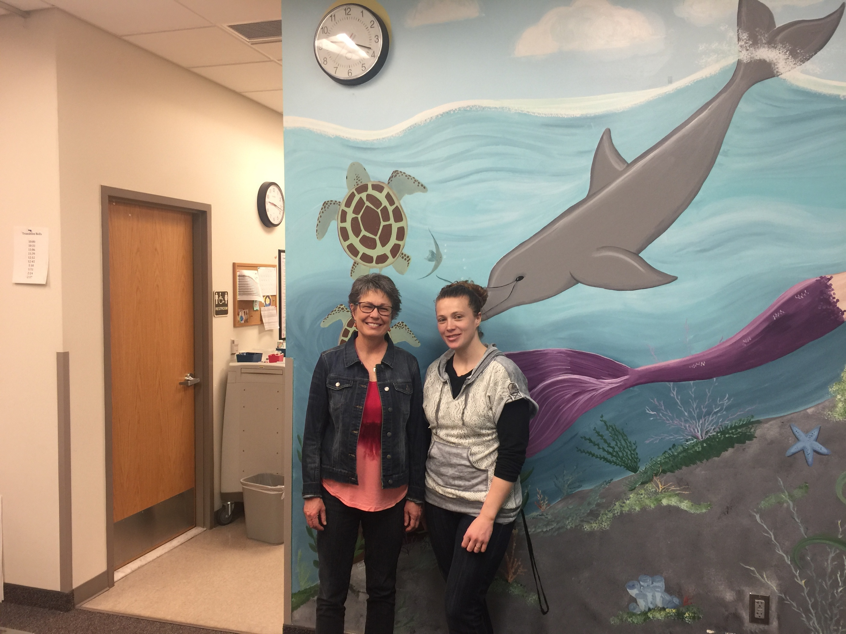
Carla Hooyer and Liz Bradshaw

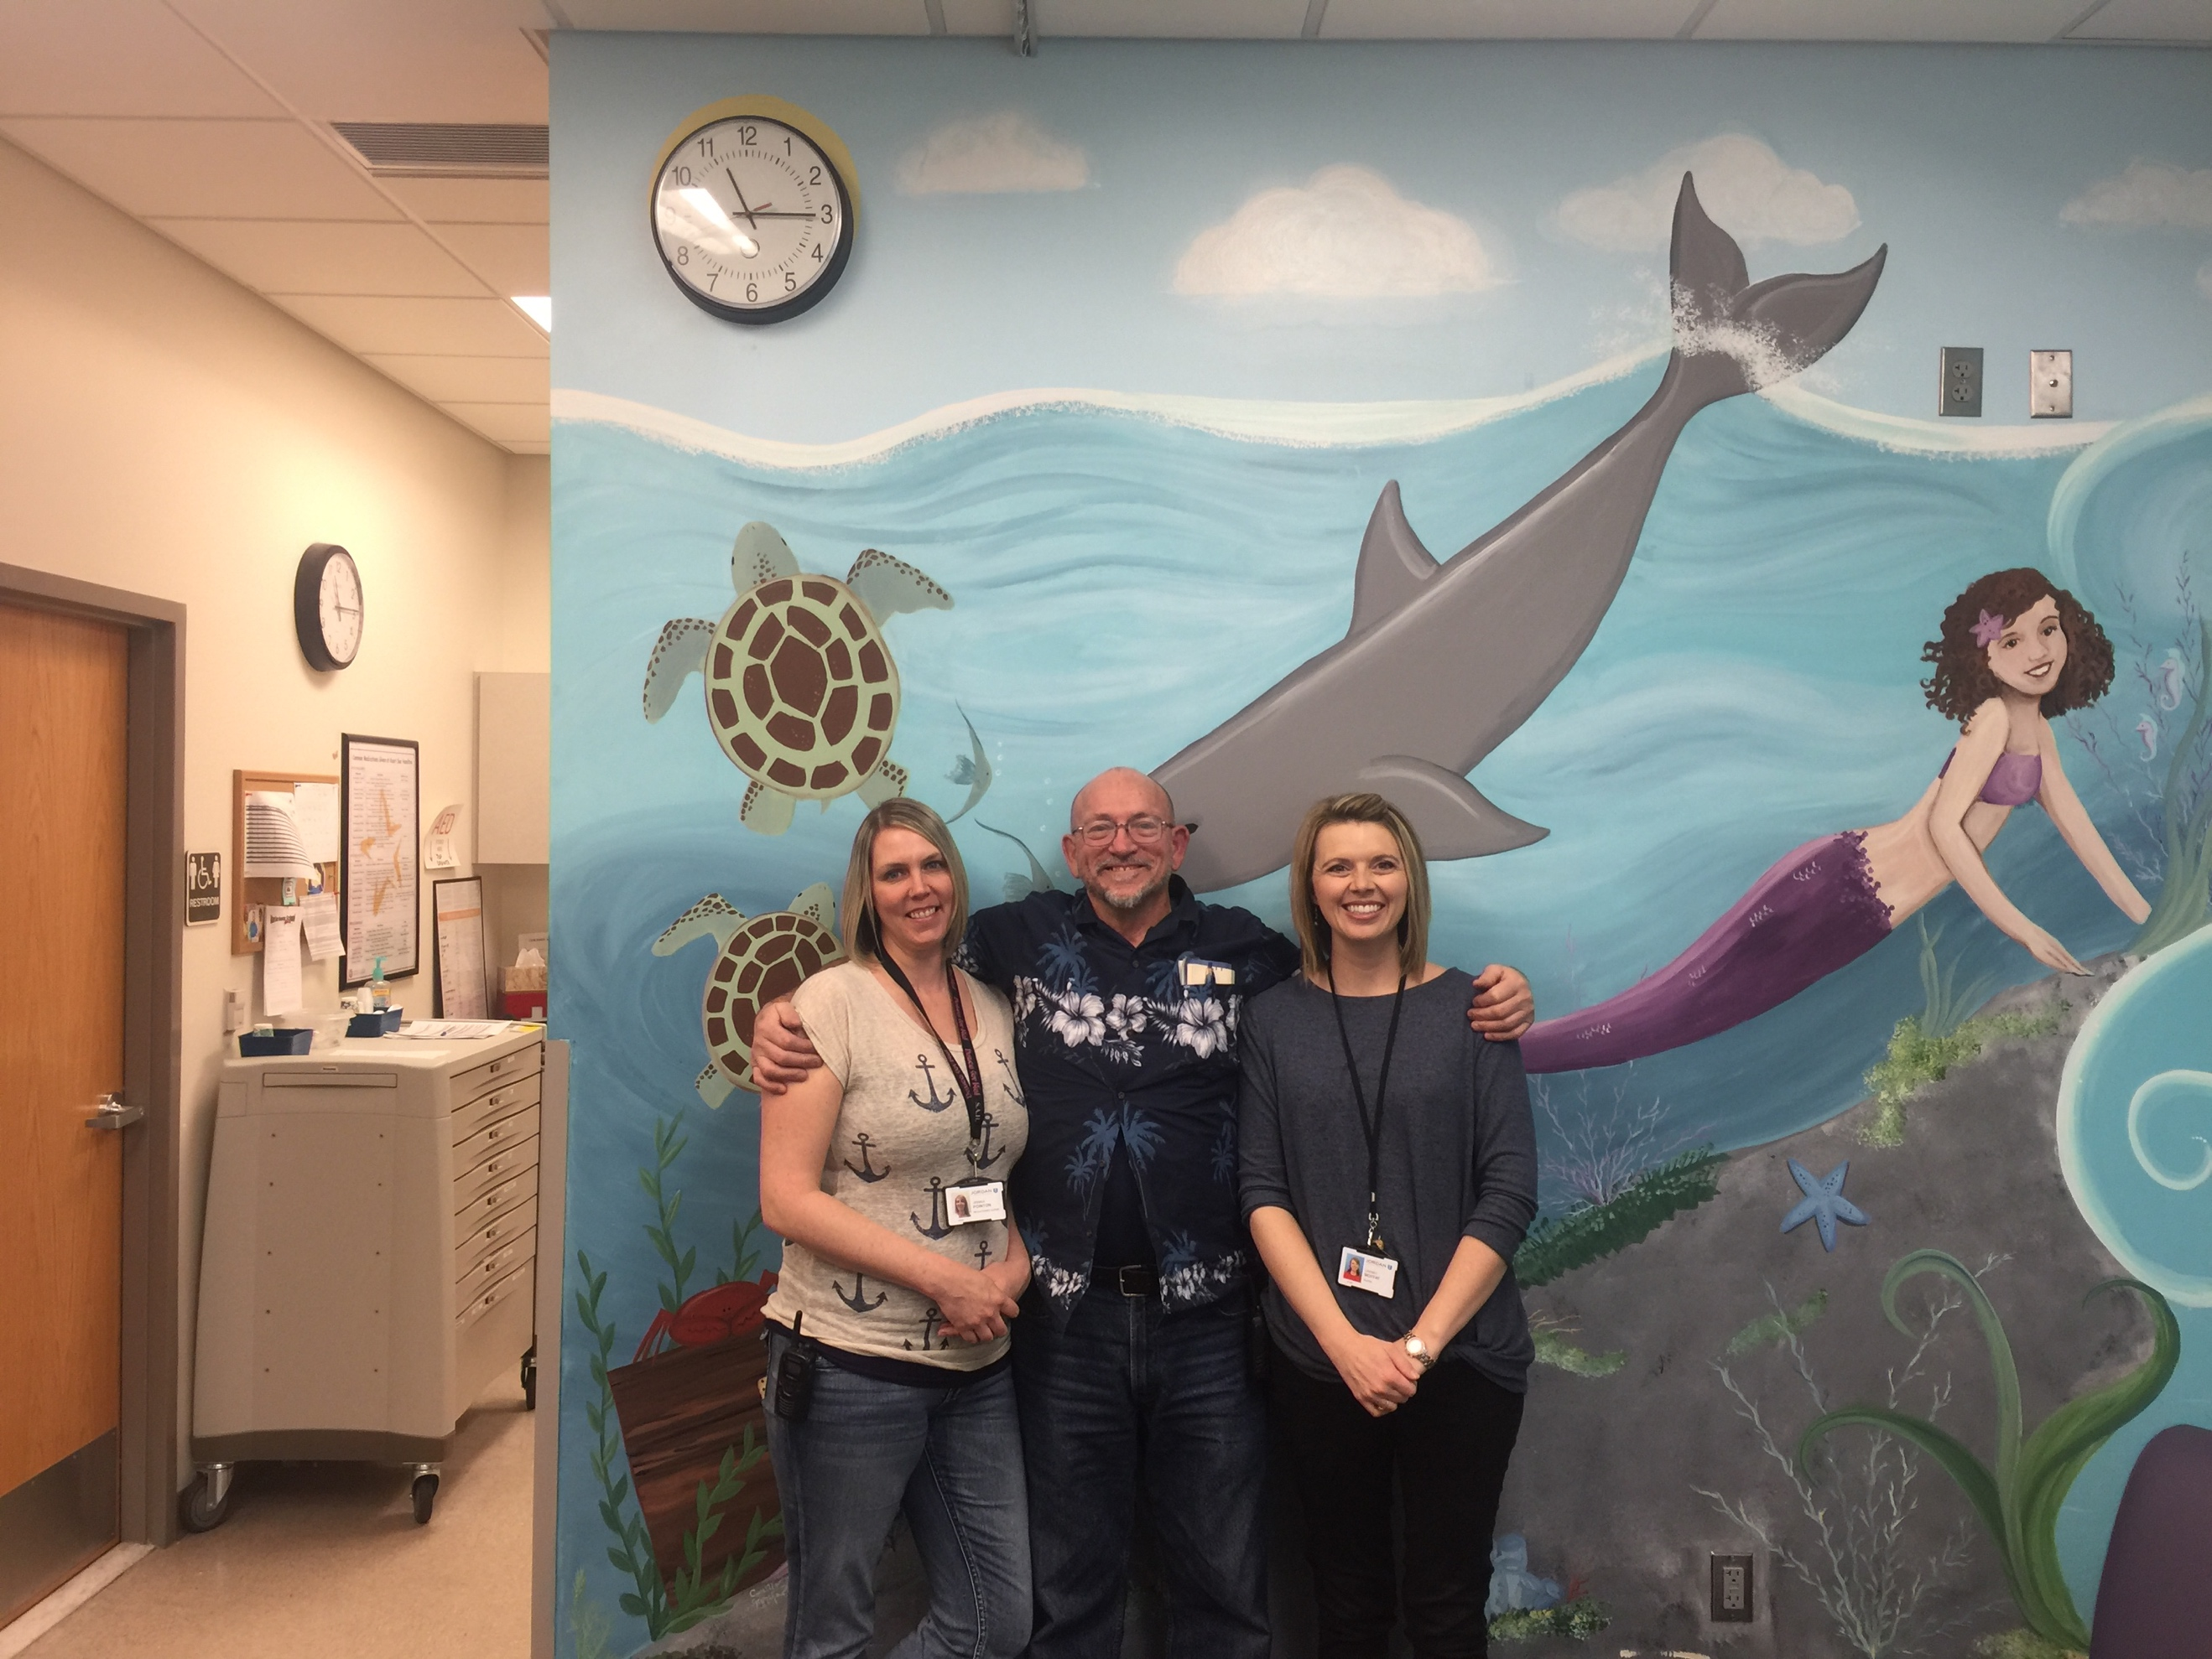
Jessica Pointon, Alan Droegemeier, Lindsey Moffat

THANK YOU, NURSES!!!

JUST DANCE!!!

Please join us on May 1st from 6-8 PM for the Starlight Dance for students ages 14 and older in the Kauri Sue Hamilton School Atrium. The Riverton High School Peer Leadership Team organizes this great annual event where our students have the opportunity to interact and dance with students within the Riverton community. Plan and joining and just dance!

THERE MAY BE A NEW SHERIFF IN TOWN, BUT THE TRADITON CONTINUES!

On March 22nd, the Salt Lake County Sheriff’s department came and delivered Easter Bunnies to our students. This is a wonderful annual tradition, and we would like to thank the Sheriff Rosie Rivera and her officers for thinking of us each year.

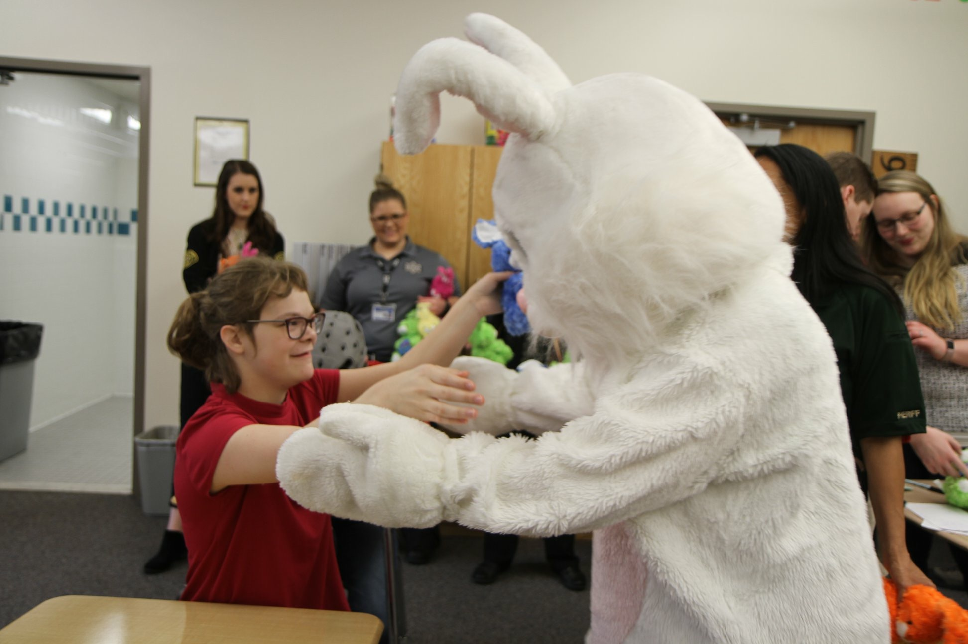

School Musical

On March 28th and 29th, Kauri Sue Hamilton held its annual musical, performing for parents and community patrons. The presentation of “Moana” was a resounding success, with enthusiasm displayed in performance, costume and set development. We want to thank everyone involved in the production: teachers, itinerant staff, as well as the Peer Leadership Team from Riverton High and their teacher Laura Taylor for their assistance in the set production process. Our staff also had the opportunity to wear t-shirts this year in support of the Spring Fling. We want to thank Tammy Hansen, a community patron, who graciously donated these t-shirts.

Finally, we want to thank staff members Maddie Nelson and Carrie Davidson. Maddie is our music therapist and has transitioned to working part-time this year. As she does every year, she went above and beyond in producing and directing this musical. Carrie Davidson, co-director, demonstrated creativity with costume and set ideas and put together some amazing props and displays. Maddie and Carrie put in many hours outside of work time to make this years' production another great success! Thank you, ladies!

We truly have an amazing staff at Kauri Sue Hamilton. The annual school musical is a reminder of the great work they do. Thank you for coming and supporting this wonderful event!

Utah Kids Club is giving away 2 Bike Camp Registrations for the 2018 Cycle Ability's Bike Camp!

Join us for the 4th annual CycleAbility & iCanShine Bike Camp for riders with special needs. This camp is inclusive of many abilities and disabilities ages 8+. Riders attend 75-minute daily sessions and learn balance and coordination on specialized roller bikes while supported by volunteers. Nearly 85% of riders learn to ride on two wheels.
Camp is June 25-29, 2018 at Summit Academy HS, Bluffdale
Check it out and register while spots are still available at www.CycleAbility.org
AND for sure, Nominate a special child to win 1 of our 2 registrations.
Go to www.Facebook.com/UtahKidsClub to enter to win!

Utah Kids Club would be so happy to send your child to bike camp this summer!

Health Services Department

Hello families of Kauri Sue! My name is Sarah Woollard and I am the new Outreach Specialist in Health Services. I am replacing Ruth Hendriksen, who is now our Administrative Assistant. My role as Outreach Specialist is to assist students and families and link them with the government services for which they are available. The backbone of our office is Health Services Coordinator, Kami Ridd. And we also have Jillian Watkins, caseworker from the Utah Department of Workforce Services. We are extremely committed to helping you and your children with insurance needs and other services.

Take Note: Open enrollment continues for Primary Care Network (PCN), which provides primary preventive health coverage for uninsured adults with dependent children who qualify based on family size and income. Call our office or visit www.health.utah.gov/pcn.

April 30th is the last day to submit an application for the Home Energy Assistance Target (HEAT) Program. HEAT provides winter home heating assistance and year-round energy crisis assistance for eligible low-income households throughout Utah.
Please call or refer someone you know to Health Services at (801)567-8515 for any questions about CHIP, Medicaid, HEAT, Marketplace Insurance and many other services.

Speech News

Speech in April
Giraffes Can’t Dance by Giles Andreae and Guy Parker-Rees will be presented to the students. They will use core vocabulary words such as ‘different, same, again’ while talking about jungle animals. We will address a variety of concepts: quality (tall/short, fast/slow), feelings ( happy/sad), and action words (stand, run, skip, dance, walk, leap, bow).

Book: https://youtu.be/zvuNjPLP9J0
Song Ideas:
“I Feel Better When I’m Dancing” by Meghan Trainor
https://youtu.be/pkCyfBibIbI

“Skip to my Lou”- alternate the action words
HAPPY SPRING!

NOTES FROM NURSING

Spring Allergies

It’s hard to believe that spring is just around the corner. We can look forward to warmer temperatures, clearer skies and new sprouts popping up. But with the warm breeze comes airborne pollen and mold spores. And if you suffer from seasonal allergies, you probably feel them with every inhale. Allergens send the body's immune system into overdrive, leading to allergy symptoms such as sneezing, a stuffy nose, and itching. In the springtime alone, which typically begins in March, hay fever — an allergy to pollen or mold — affects 30 to 60 million people in the United States.
Pollen is the biggest culprit triggering spring allergies. Medication can help treat the symptoms once they hit but there are many different steps you can follow to minimize your exposure to pollen.

- Keep windows closed and use air conditioning if you’re allergic to pollen. Don’t use fans since they can stir up dust.
- Filter the air. Cover air conditioning vents with cheesecloth to filter pollen and use high efficiency particulate air filters. Clean air filters frequently and air ducts at least once a year.
- If you have pets, consider keeping them outside. Animal dander and saliva are common allergens for many people. If you must keep your pets indoors, do not allow them in the bedroom and be sure to bathe them often.
- Use plastic covers for pillows, mattresses and box springs. Avoid overstuffed furniture and down-filled bedding or pillows.
- Limit throw rugs to reduce dust and mold. If you do have rugs, make sure they are washable. When possible, choose hardwood floors instead of carpeting.
- In the car, keep windows closed and set the air conditioner to use recirculated air.
- Check the forecast. Stay indoors as much as possible on hot, dry, windy days when pollen counts are generally the highest.
- If possible, stay indoors between 5 and 10 a.m. when outdoor pollen counts are usually highest.
- After being outdoors, take a shower, wash your hair and change your clothes to remove pollen that may have collected in your clothes and hair.

If you or your family members are bothered by these symptoms and you’ve tried some of the home remedies, check with your doctor. It may be time to try some over the counter medication or other treatment.
Most of all, enjoy Spring!!

WE ARE THE STARS!!!

